**PROPERTY LISTING ANALYSIS**

Deepanshu Singh (pd13_057)

_____________________________________________________________________________________

You are an Analyst working for a Property Rental company. The company wants to explore the trends for different property types (Room Types) and their listed price across a variety of metrics. Thus, you are asked to understand the data and come up with the below analysis:

1. Analyse **different metrices** to draw the distinction between the **different types of property** along with their price listings (bucketize them within 3-4 categories basis your understanding):

To achieve this, you can use the following metrics and explore a few yourself as well.

Availability within 15,30,45, etc. days, Acceptance Rate, Average no of bookings, reviews, etc.

1. PRICE METRICS ON PROPERTY TYPES:

**QUERY:**

Create view PT_Budget as

Select *, Case when Avg_Price< =100 Then 'Affordable'

when Avg_Price > 1000 Then 'Luxurious'

when Avg_Price between 500 and 1000 Then 'Ultra Premium'

else 'Premium'

end as 'Stay'

FROM

(Select Property_Type, avg(price) as Avg_Price from listing_dallas_df group by property_type

UNION

Select Property_Type, avg(price) as Avg_Price from listing_austin_df group by property_type)Ap;

---------------------------------------------------------------------------Select * from PT_Budget;

**OUTPUT(Sample):**

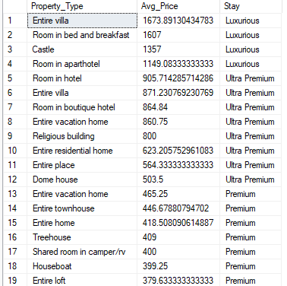

RATIONALE behind query:

* To get average price of all property types.
* A sub-query to UNION desired output from 2 cities.
* CASE WHEN for bucketizing budget type stays based on avg price.
* Created a VIEW to use query later.

1. ACCEPTANCE METRICS ON PROPERTY TYPES

QUERY:

Create VIEW Avg_ACR as

Select Property_Type, Avg(Avg_AR) as Avg_AcpR from

(Select listD.Property_Type, AVG(hostD.host_acceptance_rate) as Avg_AR from listing_dallas_df as listD join host_dallas_df as hostD

ON listD.host_id = hostD.host_id

GROUP BY listD.Property_Type

UNION

Select listA.Property_Type, AVG(hostA.host_acceptance_rate) as Avg_AR from listing_austin_df as listA

join host_austin_df as hostA

ON listA.host_id = hostA.host_id

GROUP BY listA.Property_Type)Avg_AR

GROUP BY Property_Type

---------------------------------------------------------------------------

Select * from Avg_ACR;

------------------------------ FINAL QUERY --------------------------------

Select Property_Type,Avg_AcpR,

Case when Avg_AcpR between 90 and 100 then 'Great'

when Avg_AcpR between 70 and 89 then 'Good'

when Avg_AcpR between 40 and 89 then 'Average'

when Avg_AcpR < 40 then 'Poor'

Else 'N.A.'

End as Acceptance

From

(Select B.*,A.Avg_AcpR from PT_Budget as B

join Avg_ACR as A

ON B.property_type=A.property_type)AR;

OUTPUT:

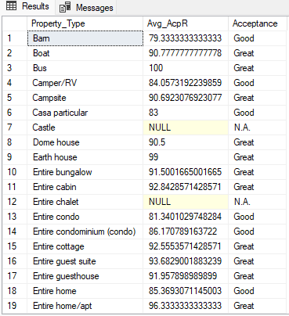

RATIONALE behind query:

* To get average
* In Sub-query, JOINed listings and hosts, followed by UNION for data of both cities, with OUTER query grouping avg of property types to eliminate duplicate property types.- Created a VIEW to use this query later
* JOIN 2 Views based on Property type in inner query and bucketized acceptance rates with a comment by using CASE WHEN.

1. RATINGS METRICS ON PROPERTY TYPES

QUERY:

Select *, Case when Avg_of_rating = 5 then 'Extraodinary'

when Avg_of_rating > 4.5 then 'Excellent'

when Avg_of_rating > 4 then 'Good'

when Avg_of_rating > 3 then 'Average'

when Avg_of_rating <= 3 then 'Poor'

else 'N.A.'

eND as 'Rating'

from

(Select Property_Type, Avg(Avg_) as Avg_of_rating from

(Select Property_Type, Avg(review_scores_rating) as Avg_ from listing_austin_df group by Property_Type

UNION

Select Property_Type, Avg(review_scores_rating) as Avg_ from listing_dallas_df group by Property_Type)Av_R

Group by Property_Type)Avg_Rate;

OUTPUT:

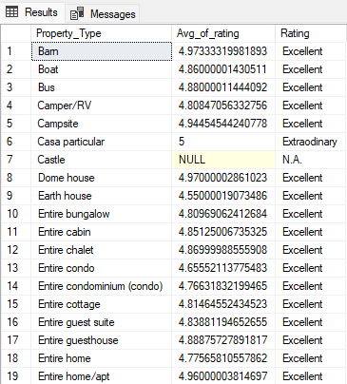

RATIONALE behind query:

* To bucketize rating categories, used a CASE WHEN.
* In the inner most query, extracted grouped avg ratings according to property types, UNIONed both Cities.
* Outer groups property types again to eliminate repetitive values.
* Outer most query is all queries and CASE WHEN bucketization.

1. BOOKING METRICS ON PROPERTY TYPES

QUERY:

Select *, Case when Number_of_bookings> 100000 then 'Most Bookings'

when Number_of_bookings < 10000 then 'Least Bookings'

else 'Moderate Bookings'

end as Bookings

from

(Select Property_Type, Sum(No_of_bookings) as Number_of_bookings from

(Select listA.property_type,count(available) as No_of_bookings from listing_austin_df as listA

join df_austin_availability as AvailA

on listA.id=AvailA.listing_id

where AvailA.available=0

Group by listA.property_type

UNION

Select listD.property_type,count(available) as No_of_bookings from listing_dallas_df as listD

join df_dallas_availability as AvailD

on listD.id=AvailD.listing_id

where AvailD.available=0

Group by listD.property_type)B

GROUP BY Property_Type)Bookings;

OUTPUT(Sample):

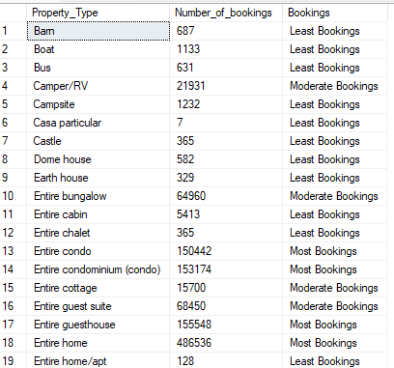

RATIONALE:

* To analyse booking numbers across property types (Assumed Availability=0 as Booking)
* In inner query, created a JOIN between listings and availability, grouped count of bookings by property types. UNIONed both cities.
* In OUTER query, Bucketized booking number to perform analysis.

1. Study the **trends of the different categories and provide insights** on same
2. Price trends across broad listing categories:

QUERY:

Select Room_Type, Min(Min_P) as Min_Price, Max(Max_P) as Max_Price, Avg(Avg_P) as Avg_Price from

(Select Room_Type, min(price) as Min_P, max(price) as Max_P, avg(price) as Avg_P from listing_dallas_df group by room_type

UNION

Select Room_Type, min(price) as Min_P, max(price) as Max_P, avg(price) as Avg_P from listing_austin_df group by room_type)PT

Group by Room_Type;

OUTPUT:

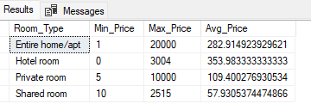

RATIONALE:

* To group price trends by category and plot those trends on charts.
* UNIONed records from both cities.

1. Acceptance trends across broad listing categories

QUERY:

Select Room_Type, Avg(Avg_) as Avg_AR from

(Select listD.Room_Type, AVG(hostD.host_acceptance_rate) as Avg_ from listing_dallas_df as listD

join host_dallas_df as hostD

ON listD.host_id = hostD.host_id

GROUP BY listD.Room_Type

UNION

Select listA.Room_Type, AVG(hostA.host_acceptance_rate) as Avg_ from listing_austin_df as listA

join host_austin_df as hostA

ON listA.host_id = hostA.host_id

GROUP BY listA.Room_Type)Acr_RT

Group by Room_Type;

OUTPUT:

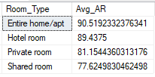

RATIONALE:

* To group acceptance across categories.
* JOINED listings and hosts with grouping by acceptance rate for room_type(categories).
* Grouped in OUTER query to eliminate repetitive categories.

1. Using the above analysis, identify top 2 crucial metrics which makes different property types along their listing price stand ahead of other categories
2. A correlation between 2 important metrics price and ratings:

QUERY:

Create View PT_Ratings as

Select *, Case when Avg_of_rating > 4.5 then 'Excellent'

when Avg_of_rating > 4 then 'Good'

when Avg_of_rating > 3 then 'Average'

else 'Poor'

eND as 'Rating'

from

(Select Property_Type, Avg(Avg_) as Avg_of_rating from

(Select Property_Type, Avg(review_scores_accuracy) as Avg_ from listing_austin_df group by Property_Type

UNION

Select Property_Type, Avg(review_scores_accuracy) as Avg_ from listing_dallas_df group by Property_Type)Av_R

Group by Property_Type)Avg_Rate;

----------------------------- FINAL QUERY ---------------------------------

Select B.*,R.Avg_of_rating,R.Rating from PT_Budget as B

join PT_Ratings as R

on b.property_type=r.property_type;

OUTPUT:

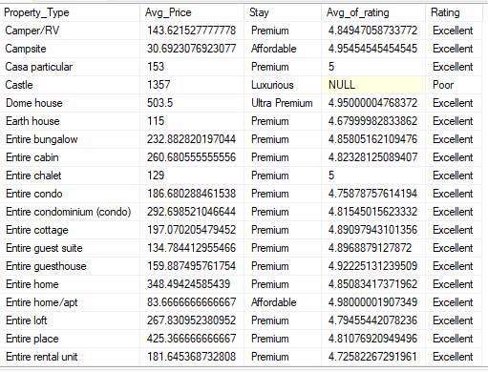

RATIONALE:

* To perform an analysis on how pricing and Stay type make an impact on rating
* Created a VIEW for Rating into and JOINED it with earlier view

1. Analyse how does the comments of reviewers vary for listings of distinct categories (Extract words from the comments provided by the reviewers)

**Variation of positive and negative comments(based on given key words) across categories:**

QUERY:

Create view list_revA as

Select listA.room_type, revA.comments from listing_austin_df as listA

join review_austin_df as revA

on listA.id=revA.listing_id;

Select * from list_revA;

-----------------------------------------------------------------------

Create view list_revD as

Select listD.room_type, revD.comments from listing_dallas_df as listD

join review_dallas_df as revD

on listD.id=revD.listing_id;

Select * from list_revD;

----------------------------------------------------------------------

Create View a_comments as

WITH P_A as

(Select Room_Type, count(comments) as Postive_comments from list_revA where

comments like '%excellent%' or comments like '%great%' or

comments like '%Awesome%' or comments like '%Good%' and comments like '%Comfort%'

group by Room_Type),

N_A as

(Select Room_Type, count(comments) as Negative_comments from list_revA where

comments like '%Bad%' or comments like '%Worst%'

or comments like '%Not good%' or comments like '%Unsatisfac%'

group by Room_Type)

Select P_A.*,N_A.Negative_Comments from P_A

full outer join N_A

ON P_A.Room_Type=N_A.Room_Type;

Select * from a_comments;

-------------------------------------------------------------------------

Create View d_comments as

WITH P_D as

(Select Room_Type, count(comments) as Postive_comments from list_revD where

comments like '%excellent%' or comments like '%great%' or

comments like '%Awesome%' or comments like '%Good%' and comments like '%Comfort%'

group by Room_Type),

N_D as

(Select Room_Type, count(comments) as Negative_comments from list_revD where

comments like '%Bad%' or comments like '%Worst%'

or comments like '%Not good%' or comments like '%Unsatisfac%'

group by Room_Type)

Select P_D.*,N_D.Negative_Comments from P_D

full outer join N_D

ON P_D.Room_Type=N_D.Room_Type;

--------------------------------FINAL QUERY--------------------------------

Select Room_Type, Sum(Postive_comments) as Comments_Positive, Sum(Negative_Comments) as Comments_Negative

from

(Select * from d_comments

UNION

Select * from a_comments)C

Group by Room_Type;

OUTPUT:

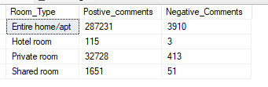

RATIONALE:

* To get the count of comments into positive and negative across categories based on set of key words.

1. Analyze if there is any correlation between property type and their availability across the months

QUERY:

Create view list_availA as

Select listA.*, availA.available, availA.date from listing_austin_df as listA

join df_austin_availability as availA

on listA.id=availA.listing_id;

--------------------------------------------------------------------------------

Create view list_availD as

Select listD.*, availD.available, availD.date from listing_dallas_df as listD

join df_dallas_availability as availD

on listD.id=availD.listing_id;

---------------------------------------------------------------------------------

Create view PT_Monthly_Availability as

With m_A as

(Select property_type, concat_ws('-',datename(month,date), year(date)) as Month_Year, count(available) as available_listings from list_availA

where available=1

group by property_type,concat_ws('-',datename(month,date), year(date))),

m_D as

(Select property_type, concat_ws('-',datename(month,date), year(date)) as Month_Year, count(available) as available_listings from list_availD

where available=1

group by property_type, concat_ws('-',datename(month,date), year(date)))

Select * from m_A

union

Select * from m_D;

-----------------------------FINAL QUERY----------------------------------------

Select Property_Type, Month_Year, Sum(available_listings) as No_Listings from (Select * from PT_Monthly_Availability)PMA

Group by Property_Type, Month_Year

Order by Property_Type;

OUTPUT:

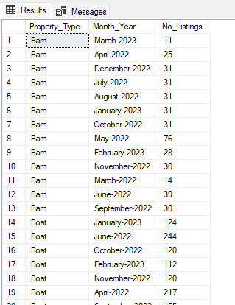

RATIONALE:

* To group Property_type on monthly basis by number of available listings, so as to perform an analysis on output.

1. Analyze what are the peak and off-peak time for the different categories of property type and their listings. Do we see some commonalities in the trend or is it dependent on the category?

QUERY:

-------------------------------------------PEAK-----------------------------------

Select room_type, Month , Year, Sum(Av) as Peak_Counts from

(

Select room_type, datepart(month,date) as Month , year(date) as Year, count(available) as Av from list_availA

where available=0 group by room_type, datepart(month,date),year(date)

UNION

Select room_type, datepart(month,date) as month, year(date) as Year, count(available) Av from list_availD

where available=0 group by room_type, datepart(month,date),year(date)

)Avail

group by room_type, Month , Year

order by room_type;

-------------------------------------------OFF PEAK-------------------------------

Select room_type, Month , Year, Sum(Av) as Off_Peak_Counts from

(

Select room_type, datepart(month,date) as Month , year(date) as Year, count(available) as Av from list_availA

where available=1 group by room_type, datepart(month,date),year(date)

UNION

Select room_type, datepart(month,date) as month, year(date) as Year, count(available) Av from list_availD

where available=1 group by room_type, datepart(month,date),year(date)

)Avail

group by room_type, Month , Year

order by room_type;

OUTPUT:

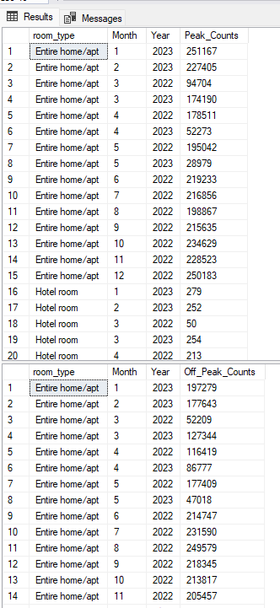

RATIONALE:

* Assumed non availability as peak and availability as off peak.
* And grouped Property_type on monthly basis by number of peak and off peak listings, so as to perform an analysis on output.

1. Using the above analysis, suggest what is the best performing category for the company

QUERY:

Select room_type, Sum(Peak_Counts) as No_of_Booking from

(Select room_type, Month , Year, Sum(Av) as Peak_Counts from

(

Select room_type, datepart(month,date) as Month , year(date) as Year, count(available) as Av from list_availA

where available=0 group by room_type, datepart(month,date),year(date)

UNION

Select room_type, datepart(month,date) as month, year(date) as Year, count(available) Av from list_availD

where available=0 group by room_type, datepart(month,date),year(date)

)Avail

group by room_type, Month , Year)Cat_Analysis

group by room_type

order by Sum(Peak_Counts) desc;

OUTPUT:

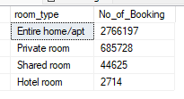

RATIONALE:

* To get number of bookings across category, so as to know best performing category for the company.
* Grouped Room_Types by number of bookings;

1. Analyze the above trends for the two cities for which data has been provided and provide insights on comparison

Comparisional analysis on below metrics/trends between two cities across listing categories:

QUERY:

-i-Average Price

Select Room_Type, avg(price) as Avg_Price from listing_dallas_df group by room_type;

Select Room_Type, avg(price) as Avg_Price from listing_austin_df group by room_type;

-ii-Ratings

Select Room_Type, Avg(review_scores_rating) as Average_Ratings from listing_austin_df group by Room_Type;

Select Room_Type, Avg(review_scores_rating) as Average_Ratings from listing_dallas_df group by Room_Type;

-iii-Bookings

Select room_type, count(available) as No_of_Bookings from list_availA

where available=0 group by room_type;

Select room_type, count(available) as No_of_Bookings from list_availD

where available=0 group by room_type;

-iv-Acceptance Rate

Select listD.Room_Type, AVG(hostD.host_acceptance_rate) as Average_Acceptance_Rate from listing_dallas_df as listD

join host_dallas_df as hostD

ON listD.host_id = hostD.host_id

GROUP BY listD.Room_Type;

Select listA.Room_Type, AVG(hostA.host_acceptance_rate) as Average_Acceptance_Rate from listing_austin_df as listA

join host_austin_df as hostA

ON listA.host_id = hostA.host_id

GROUP BY listA.Room_Type;

OUTPUT:

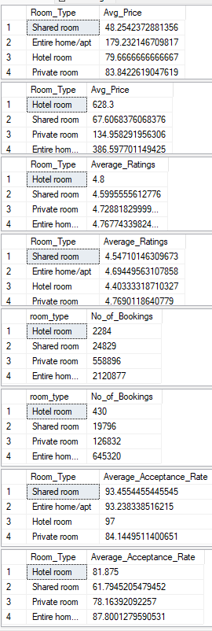

RATIONALE:

* To compare Average price, Ratings, Bookings and Average acceptance rate across listing categories between two cities.